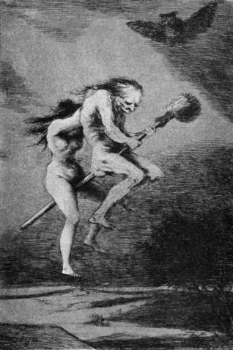
In Scotland between 1590 and 1680, it is estimated that 4,400 witches were executed. The best known case is that of the North Berwick witches in 1590-92. Among other things, they were accused of worshipping the Devil in a church at night, flying in sieves, raising storms and attempting to murder King James I by melting a wax image of him in a fire. The king took the threat seriously and interrogated them himself. One witch, Agnes Sampson, was able to whisper in the King’s ear the words he and his wife had spoken privately to each other on their wedding night. The North Berwick witches finally confessed and were all executed.
Many people believed in witchcraft. Some of the powers witches supposedly had include:
- Ability to speak with the devil
- Seeing into the future
- Communicating with the dead
- Creating spells and potions to poison or kill
- Flying
- Invisibility
- Using cats and other animals as disguises
- Influencing the weather, commonly causing storms and affecting the sea and crops

Macbeth in Context:
Witchcraft

