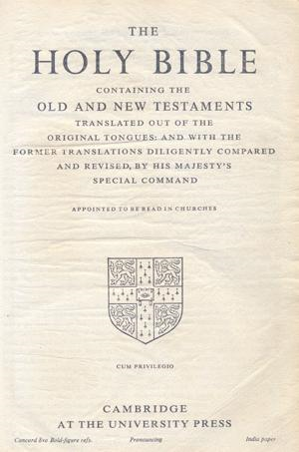

The King James Bible is published for the first time.



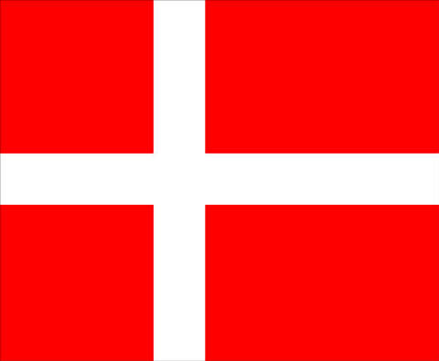

Denmark invades Sweden

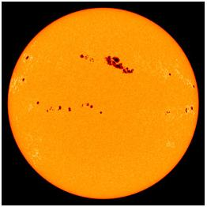

Sunspots first observed through a telescope.

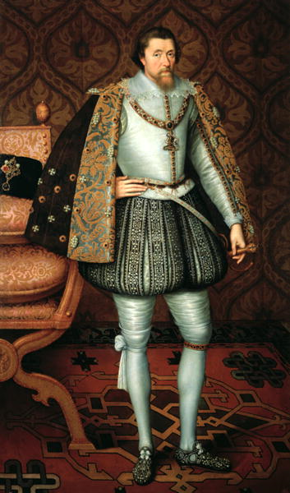
King James I of England in eighth year of his reign. A popular king, he was James VI of Scotland at just thirteen months old. An intelligent man and a great lover of literature – poetry and drama especially.

