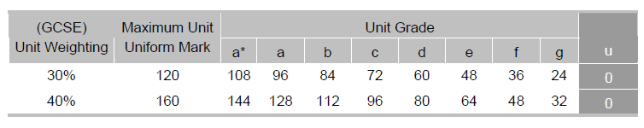
Marking of the Portfolio:

The top row is the important one for this unit. The second row is for next year’s practical piece. The 120 maximum marks is divided into three components: 60 for the essay, 40 for the practical piece and 20 for the evaluation.

Marking Criteria for Production Exercise

This assignment is marked out of 40.
Candidates will demonstrate:

Level 1 (0–10 marks)
• Candidates will produce a basic response to the task that will demonstrate minimal evidence of presentational skills in the chosen medium. There will be a very basic understanding of generic codes and conventions and some indication that there is a target audience demonstrated by candidates at the higher end of this level.

Level 2 (11–20 marks)
• Candidates will produce a competent response to the task that will demonstrate acceptable
presentational skills in the chosen medium. There will be a competent understanding of generic codes and conventions and a clear sense that the product is targeted at an audience.

Level 3 (21–30 marks)
• Candidates will produce a proficient response to the task that will demonstrate organisation and good presentation skills in the chosen medium. There will be a more thorough understanding of generic codes and conventions that are used accurately within the chosen medium as well as a very clear sense of how audiences are targeted through them.

Level 4 (31–40 marks)
• Candidates will produce an excellent response to the task that will demonstrate organisation and excellent presentation skills in the chosen medium. There will be an excellent understanding of generic codes and conventions that are used accurately within the chosen medium as well as asense of creativity and stimulation employed in targeting a specific audience.

