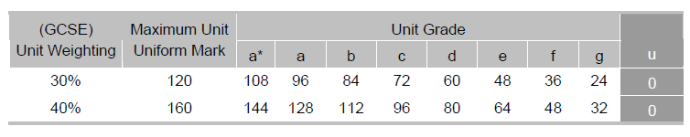
Marking of the Portfolio:

The top row is the important one for this unit. The second row is for next year’s practical piece. The 120 maximum marks is divided into three components: 60 for the essay, 40 for the practical piece and 20 for the evaluation.

Marking Criteria for Assignment
This assignment is marked out of 60.

Candidates will demonstrate:
Level 1 (0–15 marks)
• Basic knowledge and understanding of the texts studied
• Description, rather than analysis and interpretation of the texts
• Basic understanding of how texts represent social and cultural messages and values, including basic identification of those messages and values
• Basic understanding of how texts use media language and areas of representation
• Basic knowledge and understanding of codes and conventions used according to generic
categorisations of media texts
• Minimal use of technical terms and medium-specific terminology, as appropriate
• Basic understanding of the effects of techniques on texts and audiences
• Minimal reference to appropriate examples to support points made.

Level 2 (16–30 marks)
• Some knowledge and understanding of the texts studied
• Some analysis and interpretation of the texts
• Some understanding of how texts represent social and cultural messages and values, including clear identification of those messages and values
• Some understanding of how texts use media language and areas of representation
• Some knowledge and understanding of the codes and conventions according to generic
categorisations of media texts
• Some accurate use of technical terms and medium-specific terminology, as appropriate
• Some understanding of the effects of techniques on texts and audiences
• Appropriate use of some examples to support points made.

Level 3 (31–45 marks)
• Good knowledge and understanding of the texts studied
• Sound analysis and interpretation of the texts
• Good understanding of how texts represent social and cultural messages and values, including competent identification and interpretation of those messages and values.
• Good understanding of how texts use media language and areas of representation
• Good knowledge and understanding of the codes and conventions according to generic
categorisations of media texts
• Mostly accurate use of technical terms and medium-specific terminology, as appropriate
• Good understanding of the effects of techniques on texts and audiences
• Comparison of media texts, as appropriate
• Appropriate use of some examples to support points made
• Some personal insights and engagement with objects of study and concepts.

Level 4 (46–60 marks)
• Detailed and thorough knowledge and understanding of the texts studied
• Thoughtful and insightful analysis and interpretation of the texts
• Very good understanding of how texts represent social and cultural messages and values, including proficient identification and interpretation of those messages and values
• Very good understanding of how texts use media language and areas of representation
• Very good knowledge and understanding of the codes and conventions according to generic categorisations of media texts
• Accurate use of technical terms and medium-specific terminology, as appropriate
• Very good understanding of the effects of techniques on texts and audiences
• Confident comparison of media texts, as appropriate
• Appropriate use of some examples to support points made
• Personal insights and engagement with objects of study and concepts.

