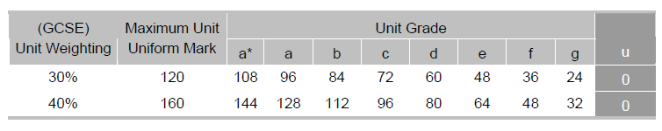
Marking of the Portfolio:

The top row is the important one for this unit. The second row is for next year’s practical piece. The 120 maximum marks is divided into three components: 60 for the essay, 40 for the practical piece and 20 for the evaluation.

Marking Criteria for Planning and Evaluative Commentary
This assignment is marked out of 20.

Level 1 (0–5 marks)
• The production will show little evidence of planning. The candidate is unlikely to demonstrate much, if any, pre-planning or research into similar media texts, technical skills, generic codes and conventions and a potential target audience or relate the work to other aspects of the unit. There will be little or no evidence of drafting. The evaluation of the finished media text will be minimal, descriptive with no or very basic medium-specific terminology being used.

Level 2 (6–10 marks)
• The production will show some evidence of planning. The candidate will have undertaken
minimal research into similar media texts, technical skills, generic codes and conventions and a potential target audience and be able to draw basic relationships to other aspects of the unit. There will be some evidence of drafting. The evaluation of the finished media text will be limited mainly to description of the production process, but with some evidence of evaluation or reflection on the work with evidence of a mostly accurate grasp of medium-specific terminology.

Level 3 (11–15 marks)
• The production will be mainly well planned, with some evidence of organised use of time. The candidate will have undertaken some limited research into similar media texts, technical skills, generic codes and conventions and a potential target audience. There will be clear evidence of drafting. The evaluation of the finished media text will be proficient with a sound sense of reflection on the work discussing how the brief related to work carried out elsewhere in the unit with evidence of a sound grasp of medium-specific terminology.

Level 4 (16–20 marks)
• The production will be well planned, with clear evidence of organised use of time. The candidate will have undertaken clear research into similar media texts, technical skills, generic codes and conventions and a potential target audience beyond those covered within the unit. There will be clear evidence of drafting. The evaluation of the finished media text will be excellent with a clear sense of reflection on the work discussing how the brief related to work carried out elsewhere in the unit with evidence of a thorough grasp of medium-specific terminology.

